TENT AGREEMENT

Check out or transfer of tent must include the following steps:
- It is the responsibility of the requesting entity to schedule for use of the tent through Thomas County Health Department. You may schedule through either Kendra Glassman or Emily Strange by calling (785) 460-4596 or by e-mail kglassman@thomascohealth.com or estrange@thomascohealth.com . Scheduling will be on a first come first serve basis. To view a current calendar schedule for the tent, click here: https://calendar.google.com/calendar/embed?src=m5kkoj4oe49jj09jvlmp7qun5k%40group.calendar.google.com&ctz=America/Chicago.
- The requesting entity is responsible for arranging pick up and return of the tent. If the tent is already checked out, contact the entity that has it or Thomas County Health Department to arrange pick up or return. Please be respectful of others scheduled timeframe and make every attempt to coordinate so each entity has adequate time for set-up and take down of the tent.
- The Tent Agreement will need to be signed by the party that is releasing the tent and the party that is acquiring the tent.
- Both parties initial beside the inventory items, which indicates that they are present when the tent is transferred. If any item is missing, please contact Thomas County Health Department immediately, as it must be replaced before the tent is transferred to the next party.
- Once all inventory items are accounted for, the acquiring party will look over tent set-up directions and ask releasing entity any questions necessary.
- If damage occurs during use, the entity will be responsible for notifying Thomas County Health Department immediately at (785)460-4596 or (785)443-0375. If it is determined that the tent was damaged by failure to follow the set-up instructions, then the party will be responsible to repair the damages.
The following inventory items must be included when transferring the tent to another agency or when returning the tent to Thomas County Health Department for storage.
Inventory Item Releasing / Accepting Party Initial Returning / Accepting Party Initials
- 1- Roller Bag _______ _______ _______ _______
- 1- Tent frame with canvas top _______ _______ _______ _______
- 3- solid 10’ side walls _______ _______ _______ _______
- 1- zippered 10’ side wall _______ _______ _______ _______
- 4- small silver tent stakes _______ _______ _______ _______
- 4- large black tent stakes _______ _______ _______ _______
- 4- pink ratchet straps _______ _______ _______ _______
- 4- white tie-down straps _______ _______ _______ _______
- Mallet _______ _______ _______ _______
- Whisk broom _______ _______ _______ _______
- Table Skirt 8’ (if applicable) _______ _______ _______ _______
If using tent inside, tie-downs are not necessary and sand bags can be used instead of anchors if desired. These are NOT supplied with the tent.
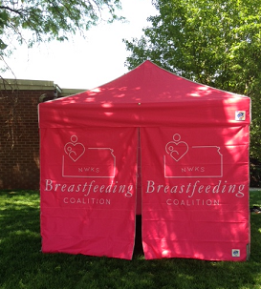

_______________________________________ _________________
Releasing Party Signature Date

_______________________________________ _______________________________________
Releasing Party Printed Name Agency

________________________________________ _________________
Acquiring Party Signature Date

________________________________________ _______________________________________
Acquiring Party Printed Name Agency

Returning Signatures

_______________________________________ _________________
Returning Party Signature Date

________________________________________ _________________
Acquiring Party Signature Date

Picture Inventory
(Not included: Whisk Broom, Mallet and 8’ Table Skirt)
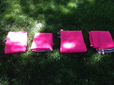
3 – solid 10’ side walls
1 – zippered 10’side wall

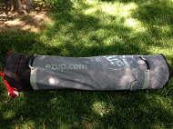
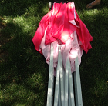
1 – roller bag
1 – tent frame with canvas
top

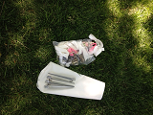
4 – small silver tent stakes

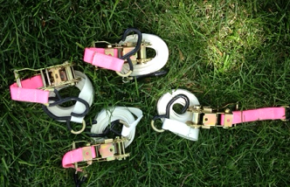
4 – pink ratchet straps
4 – white tie-down straps

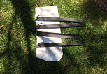
4 – large black tent stakes

Tent Set-Up-Requires a minimum of two people:
- Remove tent from roller case and stand it upright in the middle of the area where you want the tent located.
- With a partner on adjacent side of tent, grasp the lower portion of a corner leg of the frame, lift up slightly and walk backwards until the canvas top is almost fully open. This may require each person to do the same on the unattended corners as well.
- With all four corner legs extended out as far as possible, push up on the gray plastic circle located in the center, underneath side of the top where accordioned frame intersects. This will stretch the canvas top tight while extending the peak.
- On each corner of the tent top, fold up the canvas corner (it is secured to the frame with Velcro) to expose the Auto Slider Pull Pin.
- Lift up on the frame corner slightly while holding down the leg frame with the other hand. This should cause the pin to auto-engage with the hole on the frame leg when aligned. Make sure the Auto Slider Pull Pin has locked into place. Do this to all 4 corner legs.
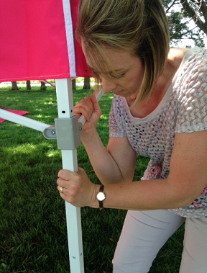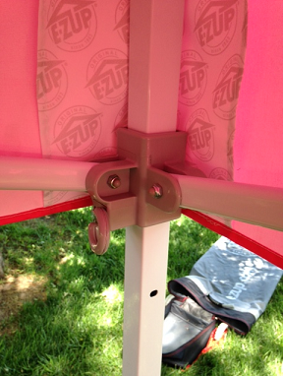
- Zip together the canvas tent sides with all pink sides facing up and gray hooks on the top edge. Leave one zipper unzipped to allow sidewall placement. (This will result in one long strip of sidewall with half a zipper on each end to be zipped together once they are hung in place.) There will be three solid sides and one front side that has a zipper in the middle.
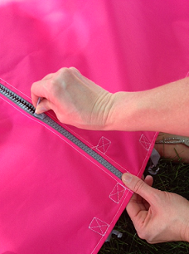
- Starting at one corner of the tent frame top, on the inside, hook the farthest gray hook on either the right or left corner of the strip of tent sidewalls to the loop that is located in the very top corner of the tent frame (make sure the pink sides are facing outwards)
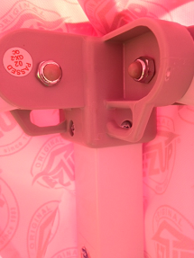
- Continue to hook the sidewalls to the tent frame making sure the walls wrap around the outside of the corner legs. Due to the Velcro attaching the top to the frame, this will require a bit of work to slide the walls around the corners at the top.
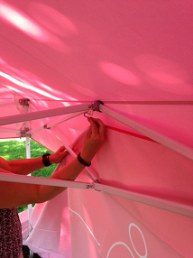
- When all the sidewalls have been attached with the gray hooks around the top, zip up the remaining zipper at the open corner to close sidewalls. Make sure the canvas at each corner on the top is turned back down to completely cover the corner. The canvas on the top of the frame will overlap the sidewalls.
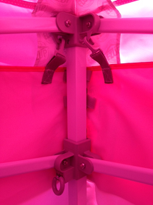
- Next, extend the leg height by stepping on the small wings on the bottom of each corner leg and pulling upwards on the leg until the toggle button engages with a hole in the lower portion of the leg. This will bring the tent up to adequate height. There are 5 adjustment settings on each leg. The third hole will be just high enough for the bottom of the sidewalls to barely touch the ground. To adjust the legs to a different height once already engaged in a hole, push in on the gray toggle button to disengage the pin in the hole and enable the leg to slide up or down. These toggle buttons are plastic, so be sure to be gentle with them to avoid breaking. (If they seem hard to push in, to disengage, slightly push down on the top portion of the leg to release tension. This will make it easier to then push in on the toggle and allow the leg to slide up and down freely). When the tent is not in use and unattended keep in lowest height for added protection from the wind.
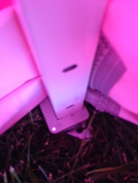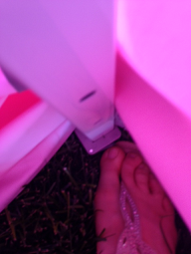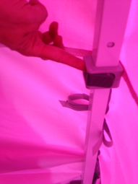
- Once the tent sidewalls are in place and the legs have been extended to desired height, secure the Velcro straps around all four corner legs on the inside.
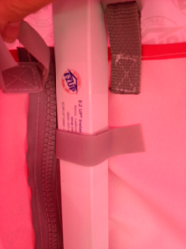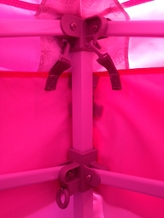

- Using small silver anchors, from the inside of the tent, hammer anchors into the ground making sure the hooks on the bottom of the anchors line up and fit into the holes in the feet of the tent legs when hammered completely down.
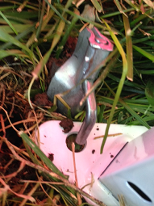

- To further secure the tent down, hook white tie down straps onto accordioned portion of top corner of tent frame by slipping the hook up under the canvas overlap from the outside and hooking it to the frame. There is no specific hole for the hook to hook into. Simply hook it around the flat metal accordioned portion of the tent frame close to the corner. The pink ratcheted portion should be near the ground attached to the lower part of the white tie down strap.
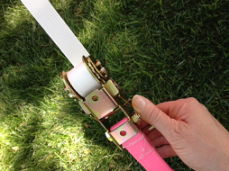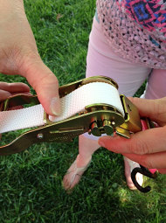

- Push large, black anchors into the ground and hook pink ratcheted end of tie down strap to the hook on the anchor. Operate ratchet until the tie down is snug, making sure not to secure too tightly.
