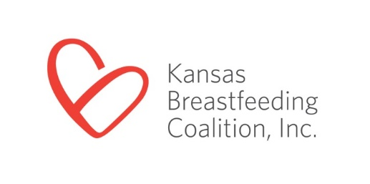
3005 Cherry Hill
Manhattan, KS 66503
785-477-4666
bbandy@ksbreastfeeding.org
www.ksbreastfeeding.org

Contact: Brenda Bandy FOR IMMEDIATE RELEASE
Phone: (785) 477-4666
Email: bbandy@ksbreastfeeding.org

Kansas Breastfeeding Advocate Receives National Tribal Trailblazer Award
MANHATTAN, Kan., March 20, 2019 – Stephanne Rupnicki, Breastfeeding Peer Counselor for the Prairie Band Potawatomi Nation, received the “Tribal Trailblazer Award” from the United States Breastfeeding Committee (USBC) for her leadership and collaborative efforts to support breastfeeding families in the Prairie Band Potawatomi Nation. Rupnicki was one of only seven individuals to receive this prestigious national award. She will attend the USBC Ninth National Breastfeeding Coalitions Convening in Bethesda, Maryland in June to receive her award.

The Tribal Trailblazer Award is given to talented and dedicated individuals who are new, emerging, or aspiring breastfeeding leaders, actively promoting maternal and child health, and breastfeeding support in their Tribes. This honor recognizes individuals of American Indian/Native American and Alaska Native heritage.
“Stephanne is an active member of the Kansas Breastfeeding Coalition. We are proud of her accomplishments and to have been able to support her work. Her passion and dedication for helping breastfeeding families in her community exemplifies the work of KBC members across the state striving to build a culture of breastfeeding support in Kansas.” said Dr. Lisette Jacobson, Chair of the Kansas Breastfeeding Coalition’s Board of Directors.

ABOUT THE KANSAS BREASTFEEDING COALITION
The Kansas Breastfeeding Coalition (KBC) is a state-wide nonprofit organization. With a mission to improve the health and well-being of Kansans by working collaboratively to promote, protect and support breastfeeding, KBC envisions a state where breastfeeding is normal and supported. To achieve this, KBC focuses its work on improving policies, systems and environments to remove barriers to breastfeeding.

###

If you’d like more information about this topic or would like to schedule an interview with Brenda Bandy, call (785) 477-4666 or email bbandy@ksbreastfeeding.org .

