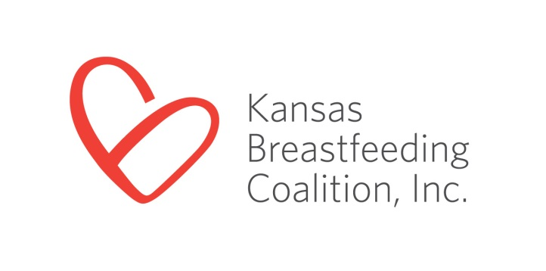

3005 Cherry Hill
Manhattan, KS 66503
785-477-4666
www.ksbreastfeeding.org

“Community Supporting Breastfeeding” Application
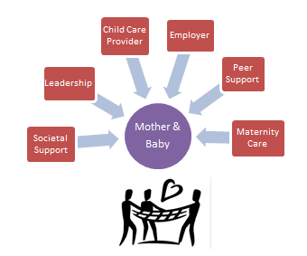
Communities in Kansas are eligible to become “Communities Supporting Breastfeeding”, a designation from the Kansas Breastfeeding Coalition (KBC) for communities who provide six key actions using existing statewide programs that address barriers to breastfeeding.

“A Community Supporting Breastfeeding” Designation Criteria | Community’s Status  “Complete” or #
A local breastfeeding coalition
Peer support group(s) such as La Leche League or similar mother-to-mother group
A least one community hospital enrolled in High 5 for Mom & Baby or Baby Friendly Hospital USA
1 business for every 1000 community citizens* or 25 (whichever is lesser) participate in the “Breastfeeding Welcome Here” program
1 business for every 5000 community citizens* or 10 (whichever is lesser) receive a “Breastfeeding Employee Support Award” from Kansas Business Case for Breastfeeding
A minimum of 20 child care providers in the community** completing the course “How to Support the Breastfeeding Mother and Family”.
**County-level data will be used when the city population is less than 20,000

*Number of citizens in the community (city or county) defined by most current census

Community Name (City or County): _______________________________________________________

Population as of most current census: ______________________________________________________

Contact Person for this application:________________________________________________________

Address: ______________________________________________________________________________

Email: ___________________________________ Phone #: ___________________________________

- Breastfeeding Coalition Name: _____________________________________________________

Meeting dates, times and location: __________________________________________________

_______________________________________________________________________________

Average meeting attendance: ______________________________________________________

When coalition formed:____________________________________________________________

Coalition Leader(s) who are current members of the KBC: ______________________________

_______________________________________________________________________________

Leadership structure (Board, informal, rotating facilitators, etc…) __________________________

_______________________________________________________________________________

_______________________________________________________________________________

- Peer support group(s) [such as La Leche League or similar mother-to-mother group]

Name of group: _________________________________________________________________

Meeting dates, times and location: __________________________________________________

_______________________________________________________________________________

Group facilitator name & breastfeeding credentials (i.e. LLL Leader, WIC Breastfeeding PC,

IBCLC, CBE, CLE, CLC, etc…): ______________________________________________________

If no breastfeeding credentials, describe approved breastfeeding education: _________________

_______________________________________________________________________________

Average meeting attendance: ______________________________________________________

- Hospital – (In cities without a maternity care hospital, “Hospital” on this form refers to the hospital serving the majority of mothers in the city)
- Enrolled in High 5 for Mom & Baby program
- Received High 5 for Mom & Baby designation
- In Baby-Friendly Hospital designation process, phase (D1, D2, D3 or D4): ____________
- Recognized as a Baby-Friendly Hospital

- Businesses** participating in “Breastfeeding Welcome Here”*: ________________ Total #
* From the “Participants” list on the KBC’s “Breastfeeding Welcome Here” page

** Each business must have a unique physical address

List of BWH businesses

- Employers receiving the “Breastfeeding Employee Support Award”*: ___________Total #
* As listed on the “Employer Awards” page of the Kansas Business Case for Breastfeeding website

Employer | Award Level  (bronze, silver or gold)

- Child care providers having completed the course “How to Support the Breastfeeding Mother & Family” ______________Total # (contact the KBC at bandy@kansas.net for this information )

Please return the completed application:

Via email to: bandy@kansas.net

Via postal mail to: Kansas Breastfeeding Coalition, 3005 Cherry Hill, Manhattan, KS 66503

Questions: Contact Brenda Bandy at bandy@kansas.net or (785) 477-4666

Thank you for creating a community supporting breastfeeding!

