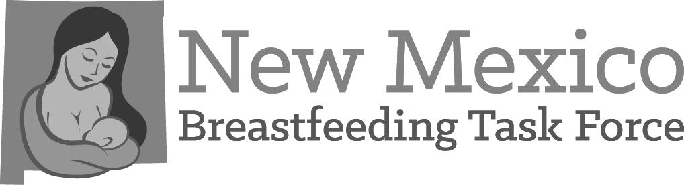

The mission of the New Mexico Breastfeeding Task Force is to improve the health of New Mexico families by creating supportive environments in which breastfeeding is the cultural norm. We strive to bridge the gap in breastfeeding disparities and are committed to making sure all families have the support they need to reach their breastfeeding goals.

Chapter Name: Meeting Date:

Name | Affiliation | NMBTF Member? | Phone | E-Mail

