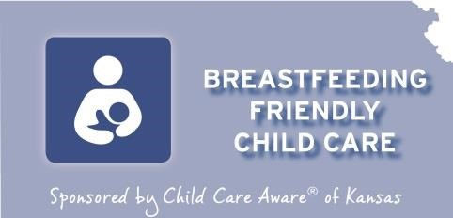
Kansas Breastfeeding Friendly Child Care Designation

Application Information

Child Care Aware® of Kansas would like to recognize child care providers in Kansas that provide support to breastfeeding families and employees through the Breastfeeding Friendly Child Care Designation. To receive the designation, child care providers must meet five criteria that demonstrate a culture of breastfeeding support. Programs receiving the Breastfeeding Friendly Child Care Designation will receive a certificate, a window cling and be recognized in the Provider Profile information that is distributed through the Child Care Aware® of Kansas Referral Center to families looking for child care.

Requirements for a Breastfeeding Friendly Child Care Designation facility
- Creates a culturally appropriate breastfeeding friendly environment.
- Has written policies that reflects their support of and commitment to breastfeeding mothers.
- Supports and provides accurate information to breastfeeding mothers and family members.
- Ensures that all staff are trained in the skills to support and promote breastfeeding.
- The facility has written policies that reflects their support and commitment of breastfeeding employee’s.
Complete the application to be considered for a Breastfeeding Friendly Child Care Designation.
Mail the completed application and a copy of all required documents to the address below:
Child Care Aware® of Kansas
Attn: Breastfeeding Friendly Child Care Designation

PO Box 2294
Salina, KS 67402-2294

Email application and materials to: kris.nicholson@ks.childcareaware.org Fax application and materials to: 785 823 3385 Attn: BFCCD

To be eligible for the designation, all criteria on the application must be met.
For more information on the Breastfeeding Friendly Child Care Designation, call Child Care Aware® of Kansas at 785 823 3343.
For more information on breastfeeding visit the Kansas Breastfeeding Coalition (KBC) website. www.ksbreastfeeding.org
The Kansas Breastfeeding Friendly Child Care Designation was developed in partnership with the Kansas Breastfeeding Coalition and the Child Care Licensing Division of the Kansas Department of Health and Environment.
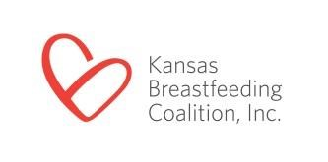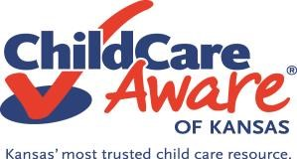

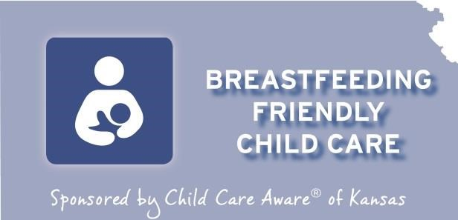

Kansas Breastfeeding Friendly Child Care
Designation Application

Name of Child Care Facility (as it appears on the KDHE license)
___________________________________________________________________________________
Address of Facility ____________________________________________________________________
____________________________________________________________________________________
KDHE License Number__________________________________________________________________
Phone Number __________________________ Email _____________________________________
Number of infants and toddlers currently in care:
____ Infants (birth-12 months)
____ Toddlers (12 months – 24 months)
____Two-year-olds (24 months – 36 months)
Number of staff, including substitutes, caring for children ages 0-3 (including program director _______
Contact Person’s Name & Title __________________________________________________________

Please read the following and obtain the signatures listed below, as applicable. By signing below, we confirm the accuracy of the information provided in this application. We agree to maintain the breastfeeding standards and procedures indicated in this application. If awarded a Breastfeeding Friendly Child Care Designation, I authorize Child Care Aware® of Kansas to list the designation as part of my Child Care Profile which is provided to parents seeking child care, be recognized at events and through social media. I also agree to display the decal provided so that is in prominent view of families and others at my facility.

Signature of Contact Person _______________________________ Date ________________________
Name of legal owner or Board Chair ______________________________________________________
Signature of legal owner or Board Chair ____________________________ Date _________________

Directions: Review each criteria and place a check mark in the met or not met box.

Criteria #1: The facility creates a culturally appropriate breastfeeding friendly environment. | Met | Not Met
Documentation: Provide photos of the culturally appropriate space along with a short narrative describing how the criteria are met.
- Culturally appropriate posters, brochures, children’s books, and other materials that illustrate best practice and demonstrate that the facility supports breastfeeding. Items are displayed in the:
  - Entrance or other public spaces
  - Infant classroom-when applicable
  - Toddler and/or preschool classrooms-when applicable
  - Space set aside for breastfeeding
- Breastfeeding mothers are provided a clean, quiet and comfortable space other than a bathroom to breastfeed their babies or express milk.
- The space has privacy, an electrical outlet, comfortable seating, sink with running water in the room or nearby and a refrigerator to store expressed milk if needed.
- The facility welcomes mothers to visit and breastfeed their babies while in our care.
- The facility allows direct breastfeeding (around the children).

Resources:
- Posters:
  - “Breastfeeding” poster (free)
  - Our Child Care Center Supports Breastfeeding Poster
  - Breastfed Babies Welcome Here poster

Criteria #2: The facility has written policies that reflects their support and commitment of breastfeeding mothers. | Met | Not Met
Documentation: Provide a copy of the facility’s written breastfeeding friendly child care policy.
- The facility has a written breastfeeding policy for families which includes:
  - Professional development for all staff (substitutes) caring for children ages 0-3 years including the program director
  - Educating families on breastfeeding
  - Providing a clean, quiet and comfortable space for mothers to breastfeed or express milk
  - Creating individualized feeding plans which include feeding infants as staff observes hunger cues and feeding are coordinated to meet the needs of the mother
  - Proper way to store and label expressed breast milk as defined by the Kansas Department of Health and Environment (KDHE)
- The policy is reviewed annually and updated to incorporate new evidence-based research and practices.
- Enrolled families are informed and provided a copy of the policy.
- Fathers are included in the discussions about breastfeeding.
- The staff informs families on how they can be supported in their efforts to continue breastfeeding.

Resources:
- Policy Sample
- BFCCD Policy Template for Programs
- Sample Child Care Center Policy Template
- Paced Bottle Feeding Video - https://www.youtube.com/watch?v=UH4T70OSzGs
- Infant Feeding Plan

Reminder: Include a copy of your breastfeeding policies in your Breastfeeding Friendly Child Care Provider application packet.
Criteria #3: The facility supports and provides accurate information to breastfeeding mothers and family members. | Met | Not Met
Documentation: Provide copies of resources and written materials provided to mothers and family members. | Met | Not Met
- Staff displays a positive attitude about breastfeeding.
- A list of community breastfeeding resources to be used for referral is updated annually.
- Families are informed about the benefits of breastfeeding and ways our program supports breastfeeding.
- Current educational materials (within the last 5 years) are available to breastfeeding families.
- Written materials are not produced by infant formula companies.
- Mothers are encouraged to exclusively breastfeed for 6 months and continue breastfeeding at least a year and beyond if mutually desired.
- Staff assists families prior to their first day in child care to transition the infant to bottle or cup feeding.
- Breastfeeding support is part of discussion with all potential infant and toddler enrollment.

Resources:
- Breast Pump Bag Tag – Parent outreach tool. Email info@ksbreastfeeding.org to order.
- Do this…Not This” Tips Sheet for Child Care Providers
- Resource List for Providers & Families
- Breastfed Babies Welcome Here guide
- Ready Set Breastfeed
- You Have Everything Your Baby Needs- English; Spanish
- Feeding Tips” card – Breast milk storage guidelines and bottle-feeding tips
- Breastfeeding 911 card To connect families and providers to local breastfeeding support
- Infant Feeding Guide – basic breastfeeding information for families
- Safe Infant Sleep and Breastfeeding Support: What to Consider When Looking for Child Care
- Care Giver of the Breastfed Baby Handout
- Breastfeeding Pamphlets
- Child Care Checklist
- Videos:
- How to Support Breastfeeding Mothers & Families: A Simple Guide for Child Care Providers (10 min. video)
- How to support breastfeeding in child care centers and family child care homes (CACFP video)

Criteria #4: The facility ensures that all staff are trained in the skills to support and promote breastfeeding. | Met | Not Met
Documentation: Provide professional development certificates of all staff, including substitutes and program director that care for children ages 0-3 years.
- Professional development for current staff on promoting and supporting breastfeeding includes:
  - Benefits of breastfeeding for mother and baby
  - Promoting breastfeeding and supporting breastfeeding mothers/families - Infant feeding cue’s
  - Proper storage and handling of breast milk
  - Bottle-feeding a breastfed baby
  - Community organizations that support breastfeeding
  - Program’s policies on promoting and supporting breastfeeding
- All staff, including substitutes and program director, that care for children ages 0-3 years have completed the course “How to Support the Breastfeeding Mother & Family”.
This course is available only through the Kansas Breastfeeding Coalition, Child Care Aware® of Kansas or Kansas Child Care Training Opportunities. This training cannot be provided by the center director or other staff.
- All staff, including substitutes and program director, that care for children ages 0-3 years are required to retake the training specified above every 3 years.
- As part of the new employee orientation, breastfeeding information is shared with all new staff within 90 days of hire.
Resources:

“How to Support Breastfeeding Mothers & Families” is available each month for FREE through Kansas Child Care Training Opportunities. Registration information. (search “breastfeed”). In-person training is also available upon request. Email request for in-person training to info@ksbreastfeeding.org. This course will increase child care providers understanding of breastfed baby behavior and how to support the breastfeeding relationship, using the latest techniques and research. Graduates of the class can proudly display the “We Care for Breastfed Babies” window decal. The class has been approved for 2 clock hours of in-service training from KDHE.

Reminder: Include professional development certificates of all staff, including substitutes and program director, that care for children ages 0-3 years in your Breastfeeding Friendly Child Care Provider application packet.

Criteria #5: The facility has written policies that reflects their support and commitment of breastfeeding employee’s. | Met | Not Met
Documentation: Provide a copy of the employee policy and photos of the culturally appropriate space that employees utilize along with a short narrative describing how the criteria is met.
- Employees make a commitment to the importance of breastfeeding.
- Breastfeeding employees are provided flexible breaks to accommodate breastfeeding or milk expression.
- Breastfeeding employees are provided a clean, quiet and comfortable place (other than a bathroom) to breastfeed their babies or express milk as needed.
- The facility has a written breastfeeding policy for employees that includes:
- Reasonable time to allow the employee to breastfeed or express as needed - Private space, not a bathroom, for milk expression

Resources:
- BFCCD Policy Template for Worksite Lactation Policy
- DOL Breastfeeding Employees Fact Sheet
- Lactation Room Guidelines
- Door Hanger – makes any room an instant lactation room. Email info@ksbreastfeeding.org to order.
- Breast Pump Bag Tag - Email info@ksbreastfeeding.org to order

* This is not required for family child care homes unless there is more than one employee.
Reminder: Include a copy of the employee policy and photos of the appropriate space that employees utilize along with a short narrative describing how this criteria is met in your Breastfeeding Friendly Child Care Provider application packet.

Be sure to check out additional information and resources….

Resources - Child Care Aware

Child Care Provider Education | Child Care videos | Kansas Breastfeeding Coalition (ksbreastfeeding.org)

